Application exercise

Summarize three texts and post your summaries in your Weebly.Quote appropriately the texts.
- How Volvo Created the Jean-Claude Van Damme ‘Epic Split’ Video By Barbara Chai

The epic split
This is an article about how was produced the Volvo Trucks comercial with the icon from brussels Jean-Claude Van Damme, 53 years old. This article revels how the stunt really happened: Van Damme was tied to safety lines and their feets on small plataforms meanwhile he performs an epic slipt beetwen two trucks on backward. Furthermore, this arcticle expresses the lastes tecnollogy for trucks: the new steering system for the truck drivers and aditionally the visión about the new landscape for Volvo comercials on TV.
Summarized made from:
http://blogs.wsj.com/speakeasy/2013/11/15/how-volvo-created-the-jean-claude-van-damme-video/

- Hey Champ, what role do science and technology play in the world's top physique? by Phil Heath

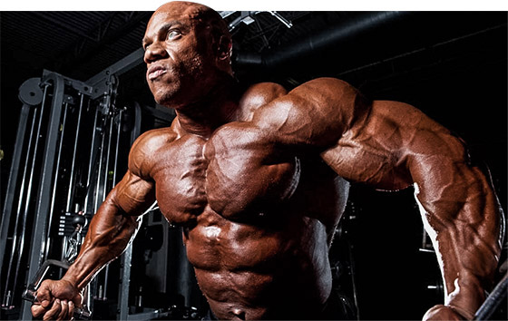

The bodibuilding of tomorrow

This is article comes from Bodibuilding.com web site, has been writte by Mr. Olympia Phil Heat and talks us about the importance of science and tecnologies for sports an athletes. Due to the fact that scientifics increasingly develops better suplements. However, the big Phil explains his thoughs related with training, suplementation, competition and her coach. Finally, he says what he thinks about the tecnology that will play an important place into judging competitions. Not only some kind od 3D machine for body scan would play a critical role, but also the stage performance and personality.

Summarized made from:
http://www.bodybuilding.com/fun/ask-the-champ-how-has-technology-helped-you-succeed.html

- Arnold's Bench Basics
The Oak's advice on proper bench press technique
By Arnold Schwarzenegger

Chest of a champion

This is an interesting article published by the austrian oak’s Arnold Schwarzenegger on Flex Magazin. It’s concerning to the best tecnics during the bench press exercise: lift the feet for train the torso stabilizing muscle, the grip withd used during the execution of the bench press and the position of elbows, among others. To conclude, the goal is keeping 8-12 reps per set and if you’re a bodibuilder and you’re looking for big pecs, don’t do mistakes, let the bigger weight to the powerlifters.

Summarized made from:
http://www.flexonline.com/training/chest/arnolds-bench-basics

Harold Rodriguez Echeverry 0328156

