The Soldier and the Death
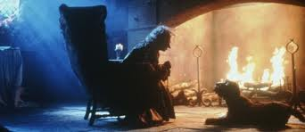
Task: Summarize the story in one paragraph.
(150 words, max).

A soldier who roamed by the world received from a beggard a beautiful whistle, a pack magic cards and a powerful sack to trap wathever he wants. He arrives to a castle with small devils and he captures and frees them, but he tear a foot of one of them. Later, due to the soldier’s son was sick, he decided to call the devil for a deal. The devil gives to him a miracle glass of water with the death spirit. The soldier saved his life’s son and then the King’s life, in change of his life. Due to He doesn´t wanted to die, he catch the death spirit into his sack for years. The soldier decided free her because people don’t dies but she never come back for him. The older soldier came to the hell and heaven but he couldn’t enter. He must return to live on earth.

Harold Rodriguez Echeverry 0328156

